WEB PAGE USING IMAGE MAPPING
DATE:31.8.10

Aim:
To create a web page using HTML image map.

Hardware requirements:
Intel pentium Processor IV
128mb RAM

Software requirements:
Jdk1.6.0

Algorithm:
- Create a HTML document
- Draw India map using MS Paint and store it in a file
- Place the image in the HTML document using <IMG> tag
- Using image map concept fix the hot spots Chennai, Mumbai, Kolkalta, Delhi in India map using <MAP> & <AREA> tags
- Create 4 relevant pages for the four cities and invoke them when the corresponding hot spot is clicked.

WEB PAGE USING IMAGE MAPPING

PROGRAM:

<html>
<head><title>India Map</title><head>
<body>
<h1 align="Center">India map<h1>
<center>
<img src="Z:\IP\image mapping\India.bmp" align="center" usemap="#Cities" height="672" width="597" TITLE="INDIA MAP" ALT="IMAGE DOES NOT EXIST">
</center>
<Map Name="cities">

<area shape="CIRCLE" COORDS="240,556,25" href="Z:\IP\image mapping\chennai.html" TITLE="This Connects to chennai" TABINDEX="1" >
<area shape="CIRCLE" COORDS="119,489,25" href="Z:\IP\image mapping\goa.html" TITLE="This Connects to goa" TABINDEX="1" >
<area shape="CIRCLE" COORDS="195,208,25" href="Z:\IP\image mapping\delhi.html" TITLE="This Connects to delhi" TABINDEX="1" >
<area shape="CIRCLE" COORDS="409,335,25" href="Z:\IP\image mapping\kolkatta.html" TITLE="This Connects to kolkatta" TABINDEX="1" >
</map>
</body>
</html>

Chennai.html
<html>
<head><title>CHENNAI</title></head>
<body BGCOLOR="BLUE" TEXT="WHITE">
<h1><MARQUEE> WELCOME TO SINGARA CHENNAI</MARQUEE></h1>
<BR><BR><BR><BR><BR>
<CENTER><h3>Intersting Places to visit in Chennai</h3></CENTER>
<CENTER>
<OL>
<LI>BEECH</LI>
<LI>VANDALOOR ZOO</LI>
<LI>SPENCER PLAZA</LI>
</OL>
<BR><BR><BR><BR><BR><BR>
<B>VISIT US AT........</B>
<BR>
www.suntour.com
</CENTER>
</body></html>

Goa.html
<html>
<head><title>GOA</title></head>
<body BGCOLOR="BLUE" TEXT="WHITE">
<h1><MARQUEE> WELCOME TO GOA</MARQUEE></h1>
<BR><BR><BR><BR><BR>
<CENTER><h3>Intersting Places to visit in goa</h3></CENTER>
<CENTER>
<OL>
<LI>BEECH</LI>
<LI>TEMPLES</LI>
</OL>
<BR><BR><BR><BR><BR><BR>
<B>VISIT US AT........</B>
<BR>
www.suntour.com
</CENTER>
</body>
</html>

Delhi.html

<html>
<head><title>delhi</title></head>
<body BGCOLOR="BLUE" TEXT="WHITE">
<h1><MARQUEE> WELCOME TO DELHI</MARQUEE></h1>
<BR><BR><BR><BR><BR>
<CENTER><h3>Intersting Places to visit in delhi</h3></CENTER>
<CENTER>
<OL>
<LI>RED FORT</LI>
<LI>PARLIAMENT</LI>
<LI>TAJMAHAL</LI>
</OL>
<BR><BR><BR><BR><BR><BR>
<B>VISIT US AT........</B>
<BR>
www.suntour.com
</CENTER>
</body></html>

Kolkatta.html

<html>
<head><title>KOLKATTA</title></head>
<body BGCOLOR="green" TEXT="WHITE">
<h1><MARQUEE> WELCOME TO KOLKATTA</MARQUEE></h1>
<BR><BR><BR><BR><BR>
<CENTER><h3>Intersting Places to visit in kolkatta</h3></CENTER>
<CENTER>
<OL>
<LI>VICTORIA PALACE</LI>
<LI>HOWRAH BRIDGE</LI>
</OL>
<BR><BR><BR><BR><BR><BR>
<B>VISIT US AT........</B>
<BR>
www.suntour.com
</CENTER>
</body>
</html>

OUTPUT:

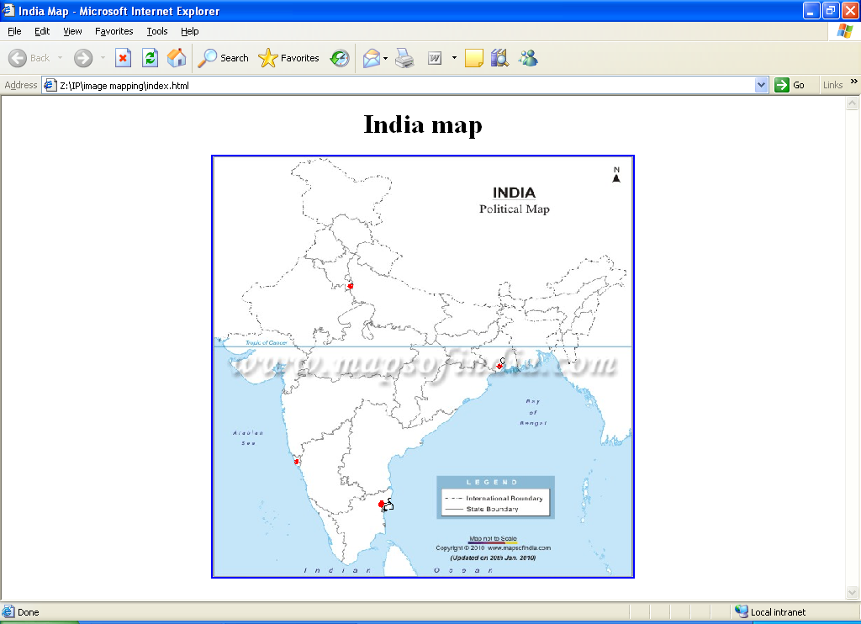

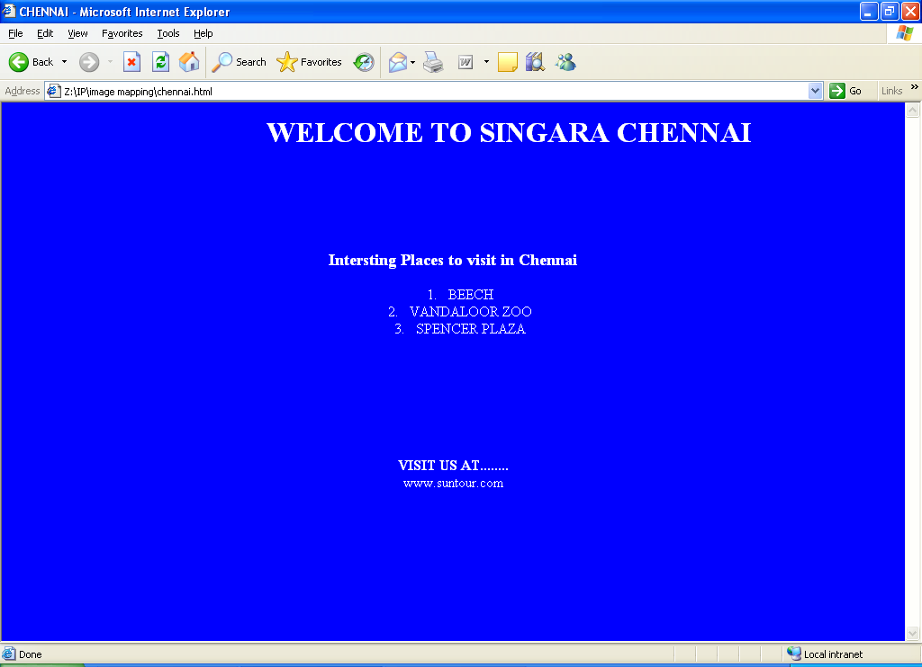

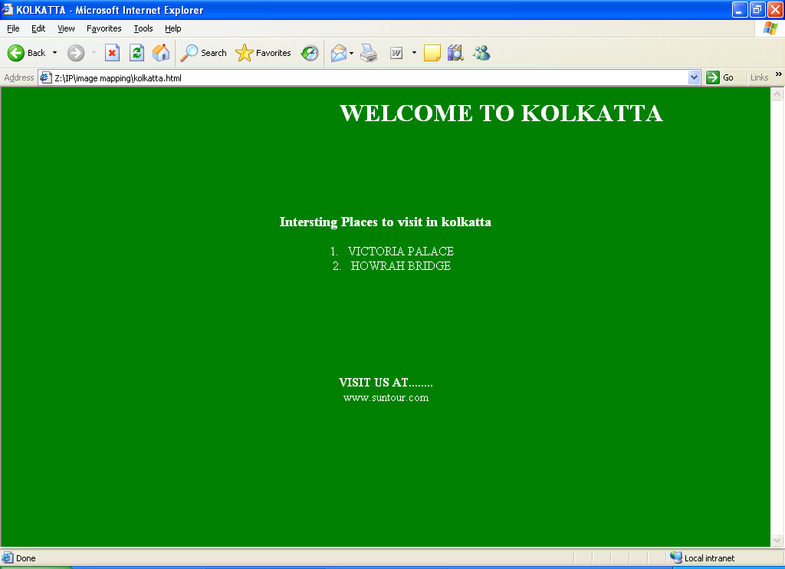

RESULT:
Thus the web page was designed using image mapping.

